Agreeable sheep Triangular cam
The Agreeable Sheep is free for everyone to download. Just click on the link on the top of the page to get started.
There are three sheets of parts. For each sheet, print out the front onto thin card (230 micron/67lb) flip the card over, return it to the printer and print out the back. If you would prefer to choose your own colour scheme there is also an uncoloured version included within the file.
Once the ink is completely dry, score along all the dotted and dashed lines, cut out the holes, then carefully cut out the parts.
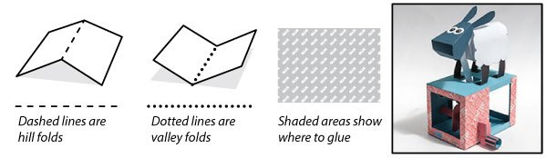

We’ll start by making the sheep.
Fold up and glue together the head.
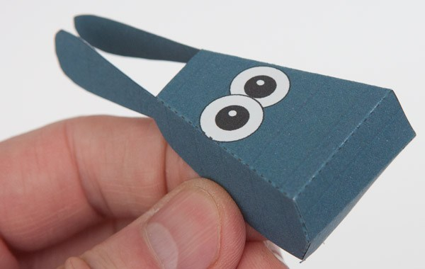

Fold up and glue together the body inner.
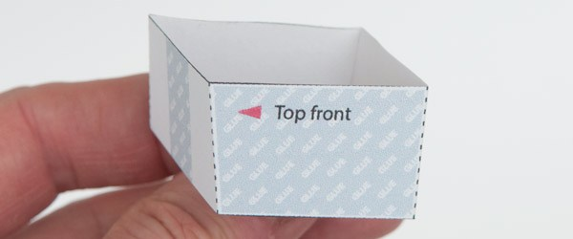

Glue the body inner into the inside of the body. The front edge corner arrowed here should be approx 3mm above the front edge of the front leg.
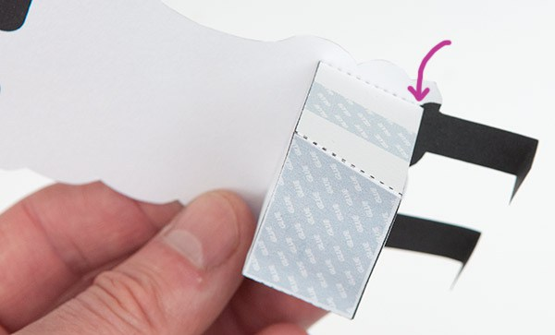

Gently curve the body round and and glue it to the other side of the body inner.
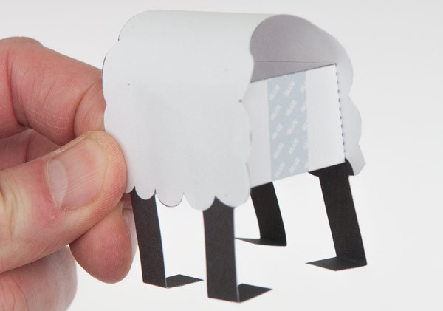

Glue the neck into place.
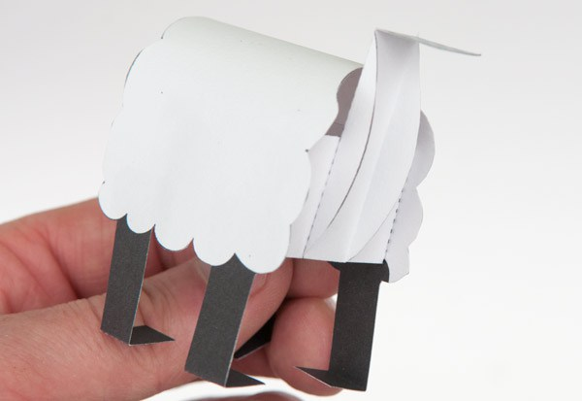

Glue the head to the tab on the neck. The head should now be free to nod up and down.
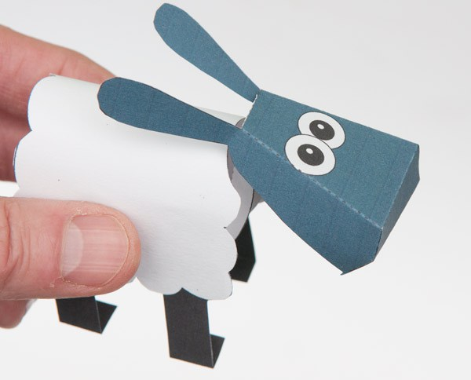

Assemble the head push rod.
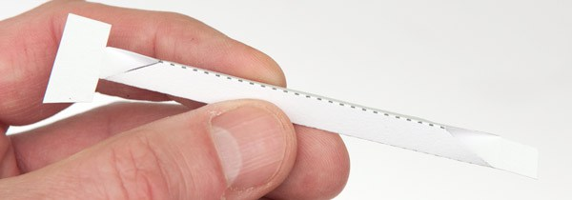

Glue the large tab on the push rod into the head. Line it up so that the crease touches the neck tab.
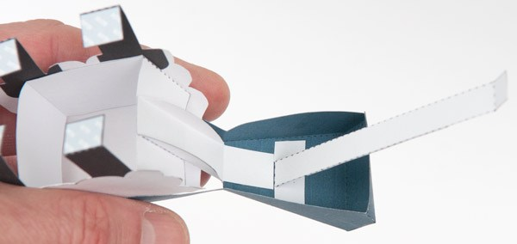

Now to make the box for the sheep to stand on.
Fold up and glue down the box top. The three triangular tubes should all be right angled triangles.
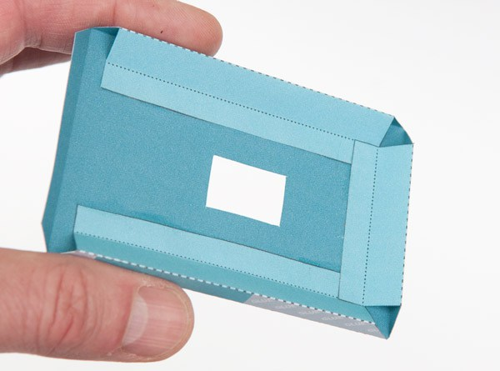

Thread the push rod down through the hole in the box top. Glue the feet to the marked areas.
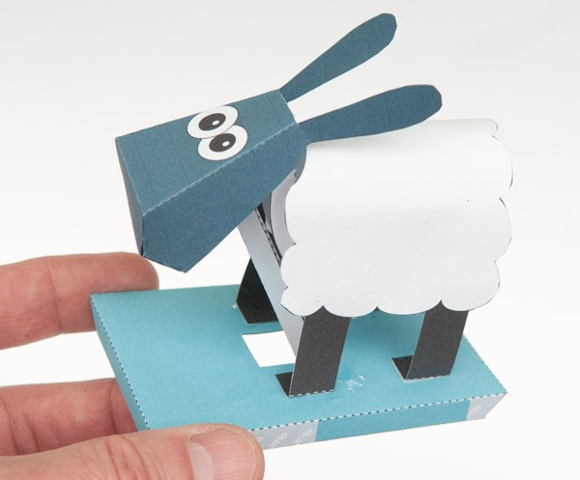

Assemble the cam follower.
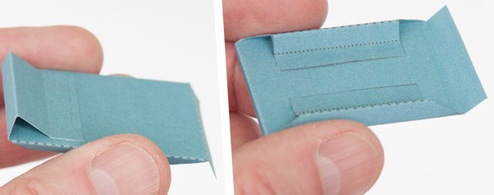

Fit the cam follower end into place lining up the end with the cam follower front.
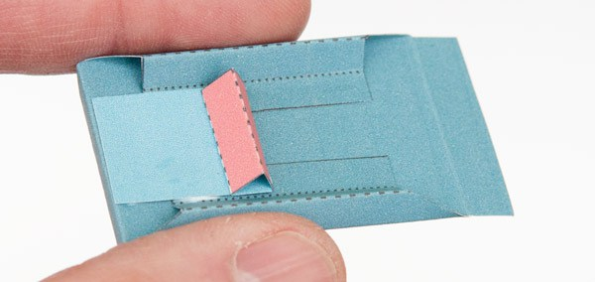

You’ll need two small coins as weights. UK one pence pieces are the perfect size. (20mm diameter 4gram weight) US$ cent and Euro cent are also a good fit. Wrap a strip of scrap card round the coins and glue it shut. Glue the coin pack to the top of the cam follower.
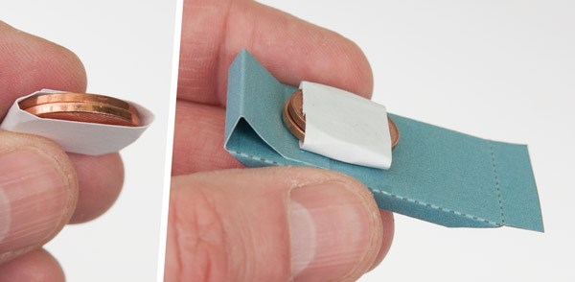

Glue the cam follower to the front of the box top. Glue the push rod to the other end of the cam follower. If you lift the cam follower with your finger the sheep should nod.
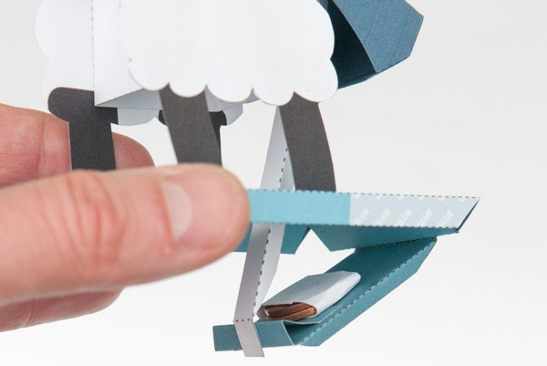

Make the triangular cam by folding over the card piece into double thickness card then, once the glue is dry, carefully cut it out.
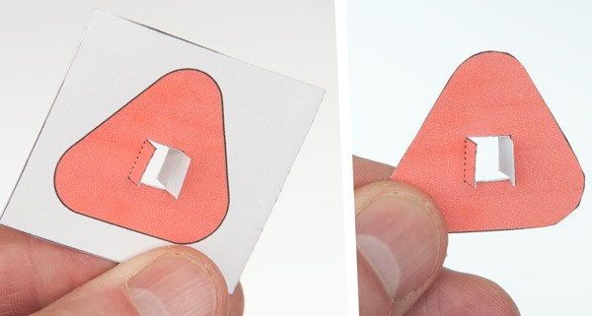

Thread the cam onto the cam shaft lining it up with the grey line.
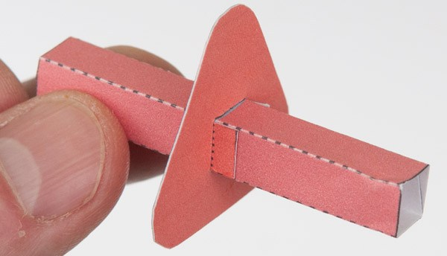

Roll up the axle and glue it down lining up the ends accurately against the five arrow heads.
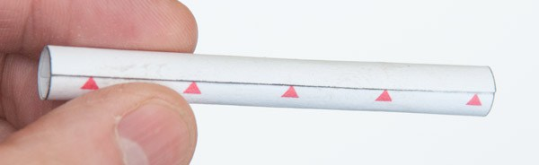

Fold round and glue down the tabs at the ends of the box front to make triangular tubes.
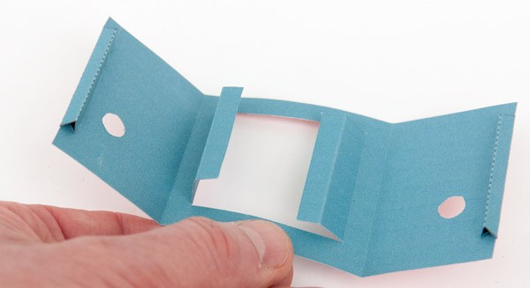

Glue the box front to the front edge of the box top as accurately as possible.
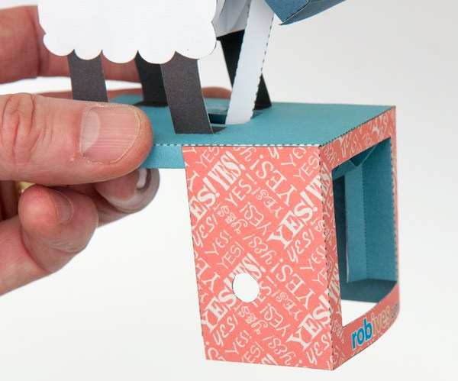

Thread the axle through one hole, through the cam shaft and out of the other hole. There should be slightly more axle to the right of the box as this is where the handle will fit.
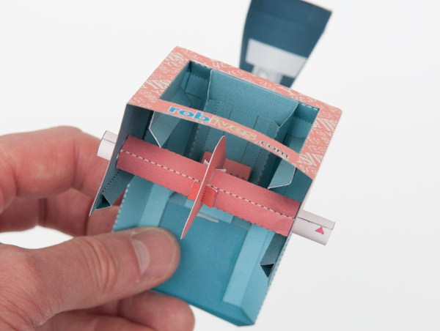

Glue the back of the box to the box top. Don’t glue the sides down yet.
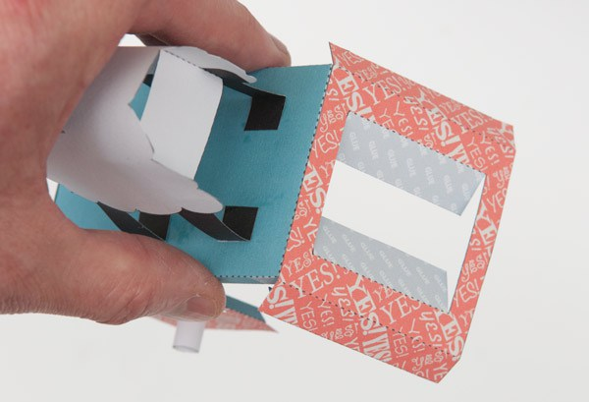

Assemble the box base with right angled triangle sides in the same way that you made the top. Glue the base to the back.
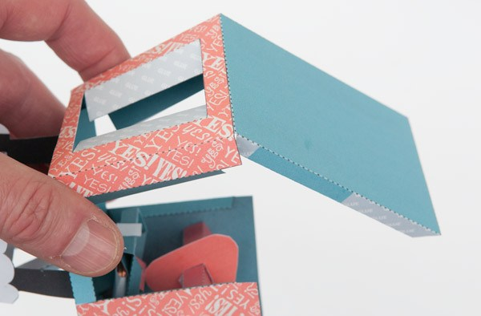

Glue the base to the front closing the box. Glue the side flaps front and back, into place.
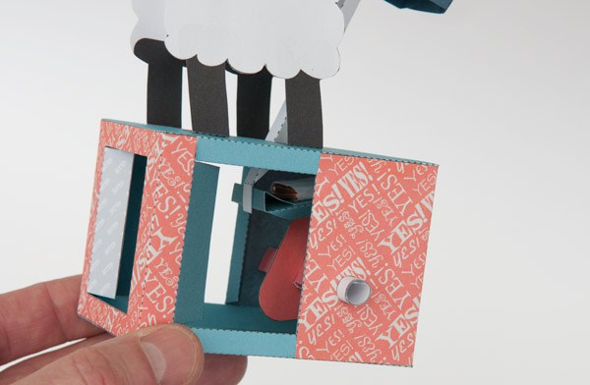

Fold in the flaps on the front of the box and glue them to the inside of the box walls.
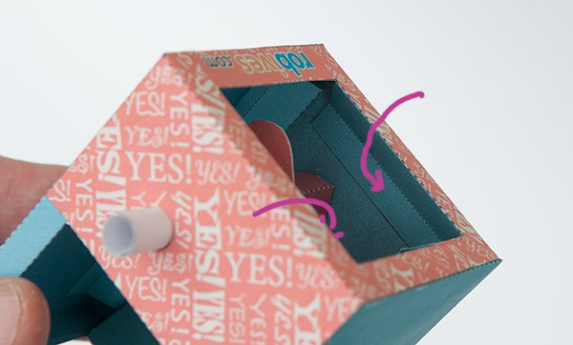

Glue together the tabs in the box back to make triangular tubes.
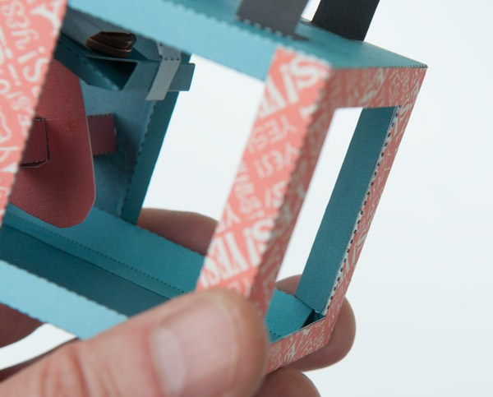

Assemble the handle in three steps.
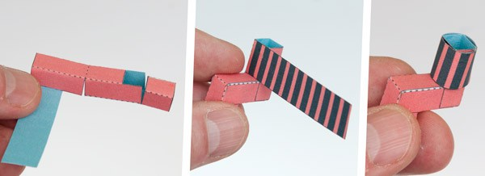

Glue the handle into place.
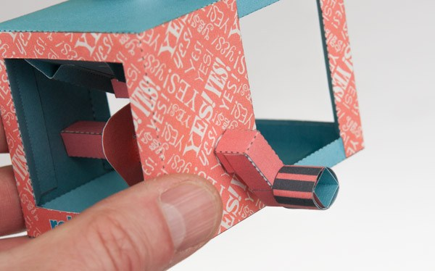

Turn the handle on your completed Agreeable Sheep.
Did it work? Yes, yes, yes!
