Design a Candy Dispenser Team of 2

Problem Statement:
A candy company needs a miniature candy machine for their 50th anniversary. The machine must be able to dispense 2 types of candy.

Design Statement:
You must build a new miniature candy machine. To help create the machine, you must use the Autodesk Inventor Pro CAD software. Possibly animate you're machine during the Inventor process.

Constraints:
- Must be durable.
- Must not exceed 24”x24”x24”.
- Must have 4 or more parts.
- Must have 2 types of candy. You decide the candy.
- Candy cannot exceed ½” for all measurements.
RUBRIC:
Product Design | Points
Define the Problem | 5
Research the Problem | 10
Develop Possible Solutions | 15
Choose the Best Solution | 5
Create a Prototype | 60
4 parts (10pts each), assembly (20pts),
Test and Evaluate | 10
Communicate | 20
Redesign | 5
Total Points | 130

Use the Engineering Design Process to help with your planning and create a poster/blog to document your design ideas using your OneDrive – Title the page with your name .
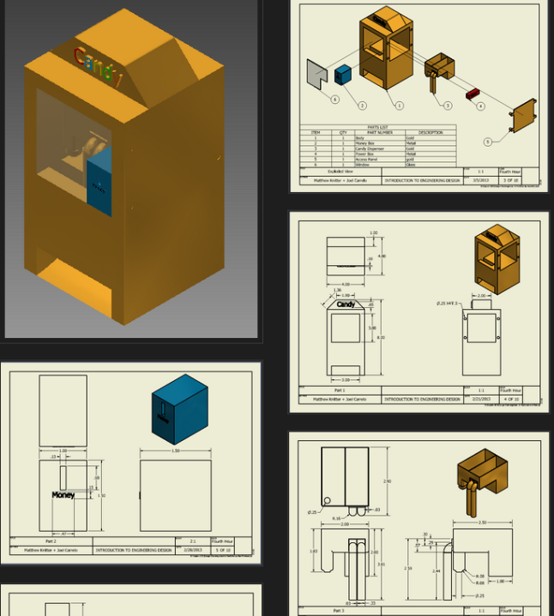
- Define the problem
- Research – include a list, picture, and description of 5 designs that already exist.
- Develop possible solutions – create 3 solutions. Take a picture and insert it into your poster/blog.
- Choose the best solution – create a pugh chart using the criteria and constraints to choose your design.
- Create a prototype – draw each of the 4 parts using AutoDesk Inventor and make an assembly animation. Lookup how to do it…remember the trains. Include copies of the drawings in your poster/blog. You can use the snipping tool under accessories to help with this. Remember to include your candy.
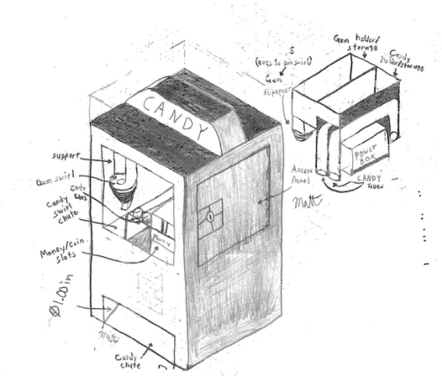
- Test and Evaluate – what changes would you make to your design now that you have drawn it?
- Communicate – your poster/blog will be your communication.
Example documentation for
create a prototype
- Redesign – what changes would you make?
Example of brainstorming drawings

