Gear it up – gear increase for speed
Gear Up! Turn the handle and the big gear with twenty nine teeth drives the smaller eleven tooth gear.
The small pinion is geared up by almost three times the speed.
This Essential Mechanism can be made as a pure mechanism or as a starting point for other character based automata. Have fun!
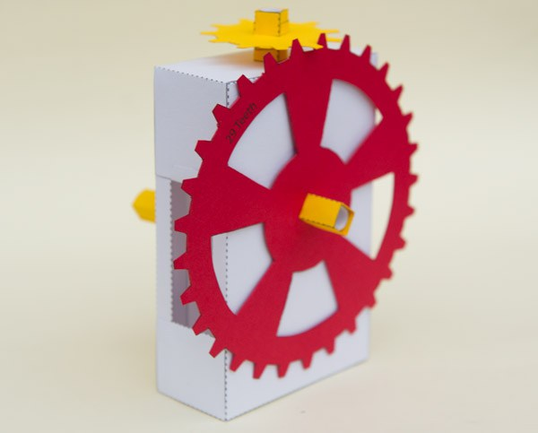

Check out the video of the model in action.
As an Essential Mechanism all paid members can download the parts of this model for free. Thanks for signing up! Non-members can join in the fun for £2.50
Print out the parts onto thin card. I used a combination of white and coloured card to make a colourful model.
Score along the dotted and dashed lines and cut out the holes before carefully cutting out the pieces.
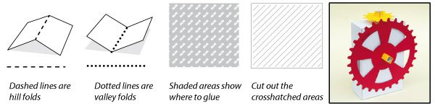

All the parts ready to go.
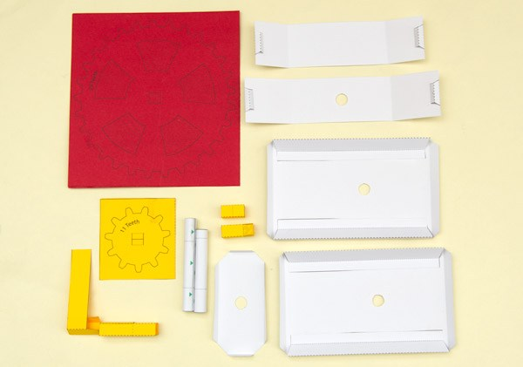

Fold over and glue down the gears to make double thickness card. Once the glue is dry carefully cut out the parts. There are detailed instructions on making gears here.
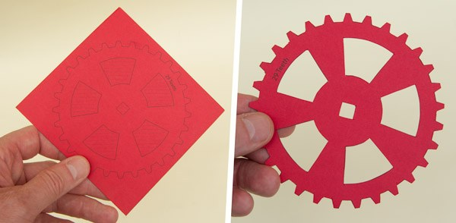
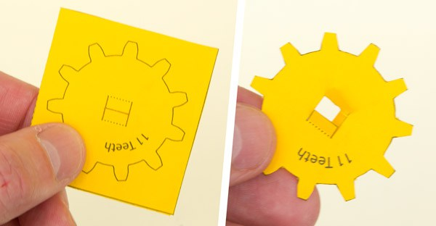

Fold up and glue the box sides making right angled triangle tubes.
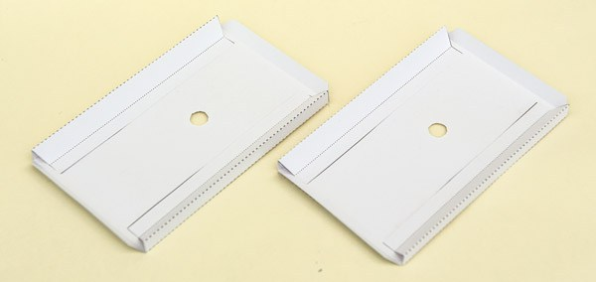

Fold round and glue the tabs on the box top and the box base making equilateral triangle tubes.
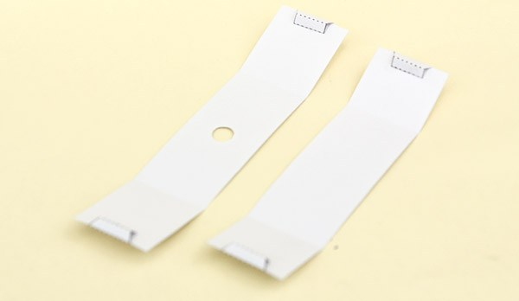

Glue the sides to the box top. Note that the holes in the sides are closest to the top piece.
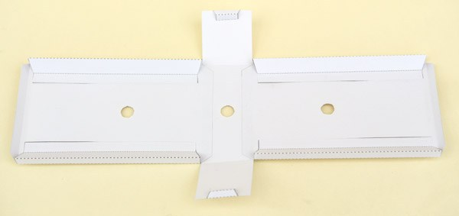

Glue the base into place.
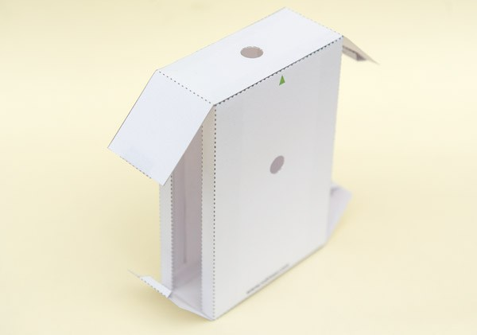

Glue down the side tabs to close the box.
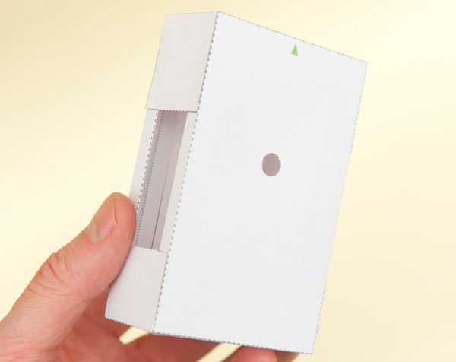

Fit the box inner into place under the box top. Note that in this picture the box is upside down.
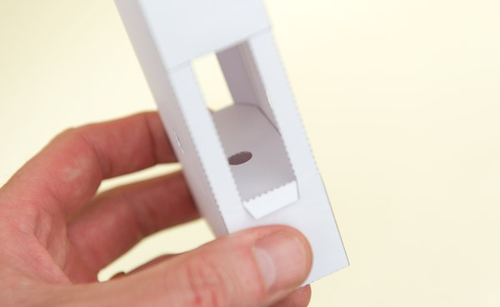

Roll round and glue down the two axle tubes lining up the edges with the points of the arrows as accurately as possible.

Thread the small gear onto the square axle tube and glue it down lining it up with the grey centre line.
Fit the gear onto the ‘Small Gear’ axle.
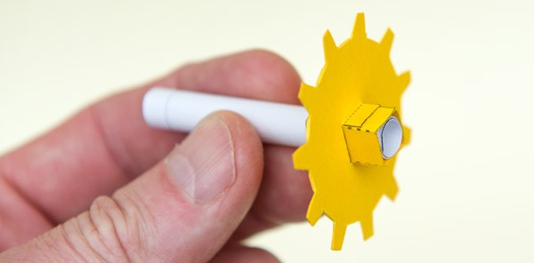

Drop the axle down through the two holes in the box top. The gear should be free to turn easily.
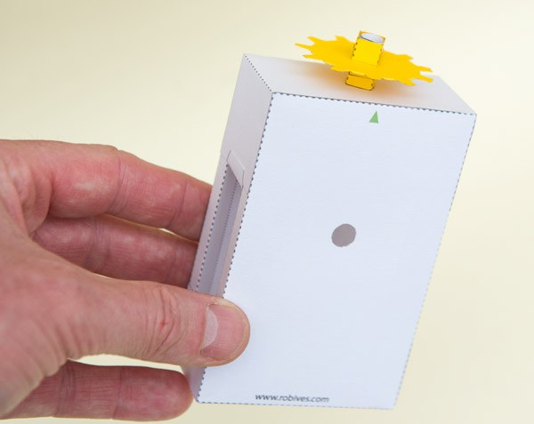

Assemble the handle in three steps.
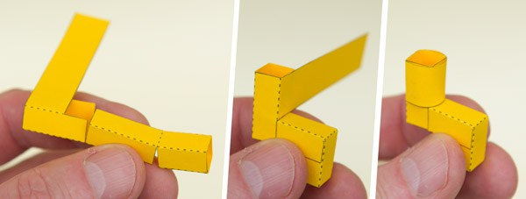

Glue the handle to the ‘Big Gear’ shaft.
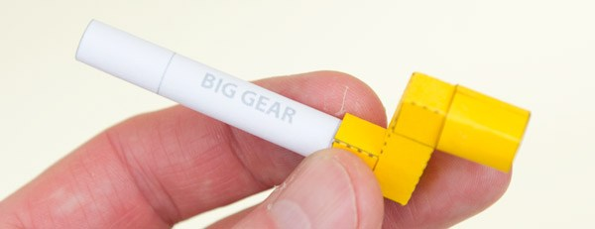

Thread the axle through the box as shown.
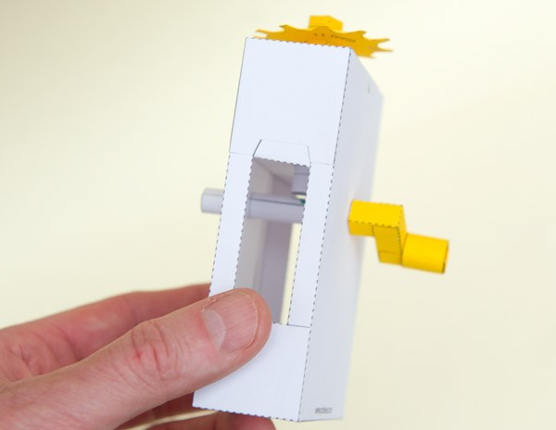

Glue the shaft stub into place in the large gear.
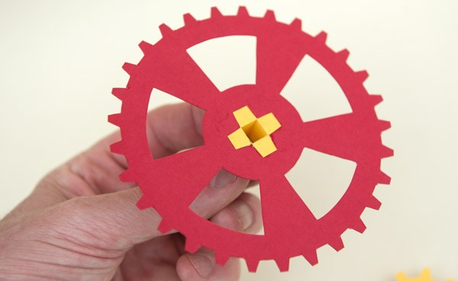

Complete the model by gluing the large gear to the axle.
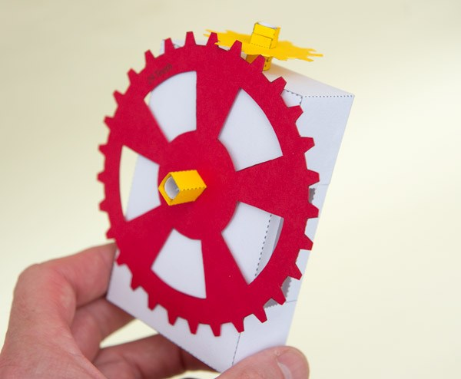

Turn the handle and watch the small gear spin!
There is something really satisfying about watching gears meshing, I love it!
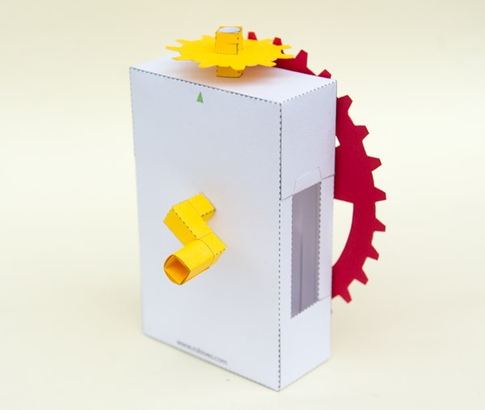

Related

