Gears and mechanisms
Square shaker, dual cam
The Square Based Shaker, Turn the handle on this Essential Mechanism and the vertical shaft turns briskly back and forth. Use the shaker mechanism as an interesting demonstration of pure paper engineering or as a starting point for your own character based paper automata. Members and Patrons can download the parts for free from the link, thanks for your support! Non-members can join in the fun for £2.50. Become a member now and you can download this and all the other projects on the site for free! More details here.
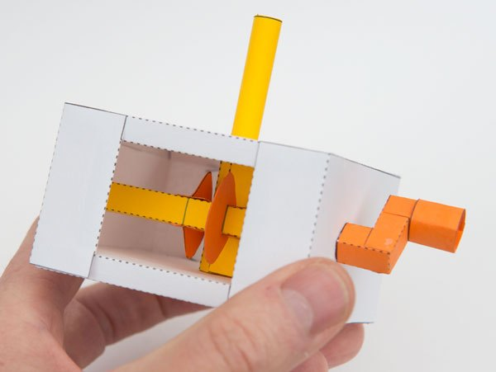

Print out the parts onto thin card. (230 micron / 67lb) I used coloured card to make a colourful model.
Score along the dotted and dashed lines and cut out the holes before carefully cutting out the model.
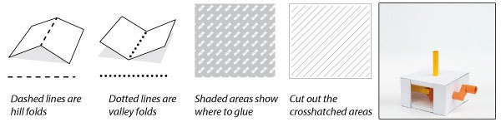

Check out the Instagram animation here.

The cam fingers are made from double thickness card. Fold them over and glue them down making sure not to glue down the tabs.
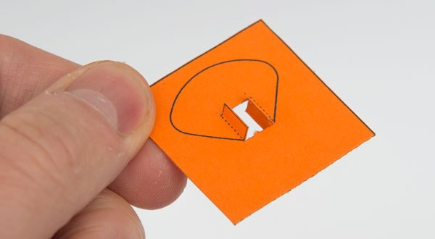

Once the glue is dry carefully cut them out.
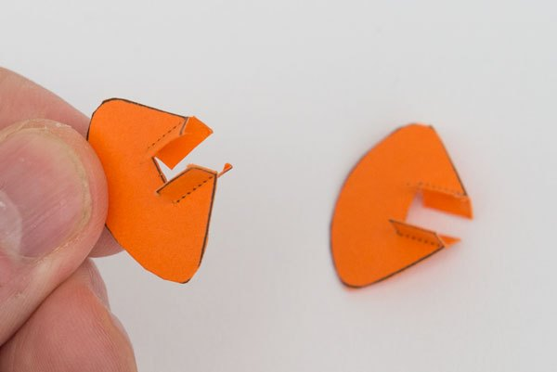

Make up the axle outer and glue the cams into place.
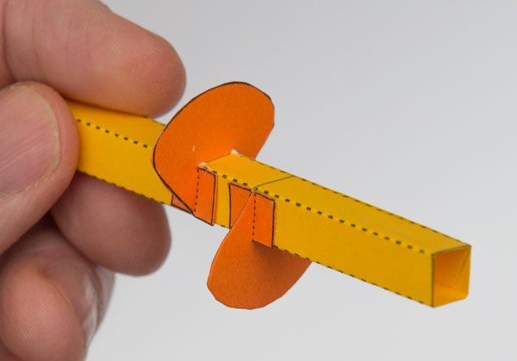

Roll round and glue the two inner axles as shown.
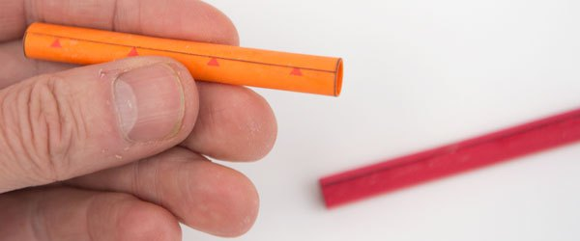

Thread the cam shaft axle into place and fix it with a dot of glue.
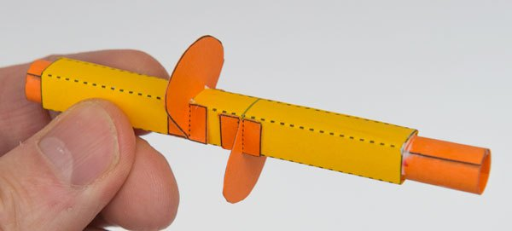

Assemble the handle in three steps.
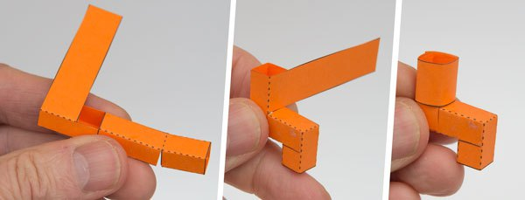

Make up the striker plate as shown.
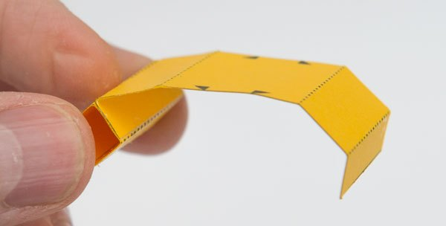
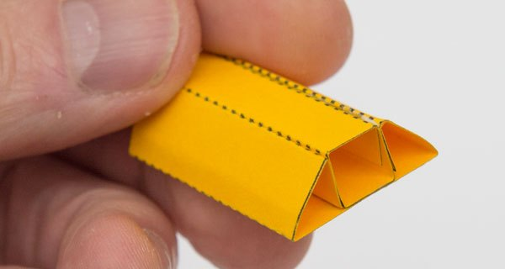

Thread the vertical axle into the striker plate assemble as shown and fix with a dot of glue.
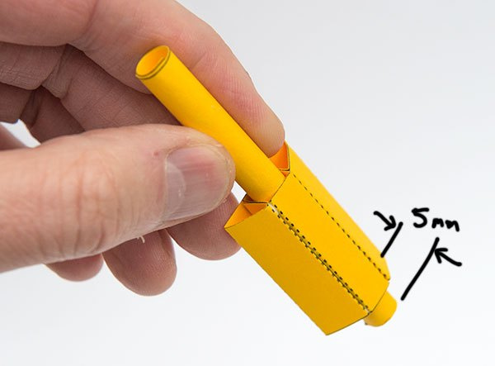

Fold round and glue down the tabs on the top and base of the box making right angled triangle tubes.
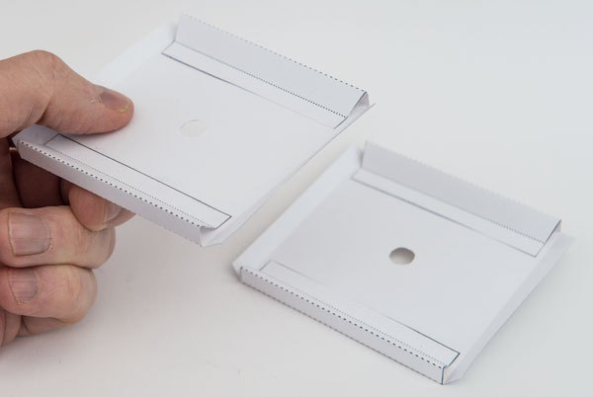

Fold in the side tabs making equilateral triangle tubes.
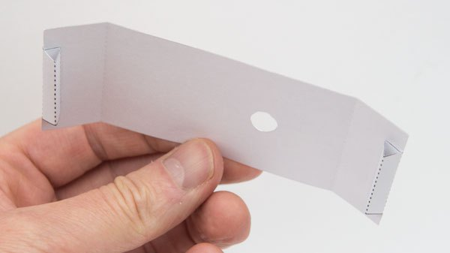

Glue the base to one of the sides lining up the edge of the tab with the edge of the side as shown.
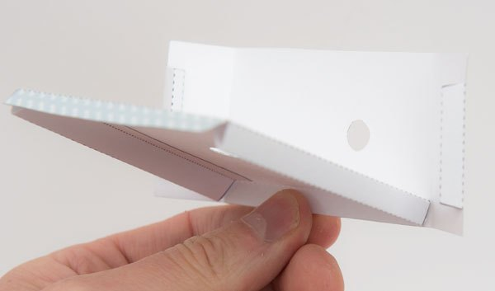

Glue on the other side then glue the top to one of the sides. Make sure that the holes on the sides are opposite each other.
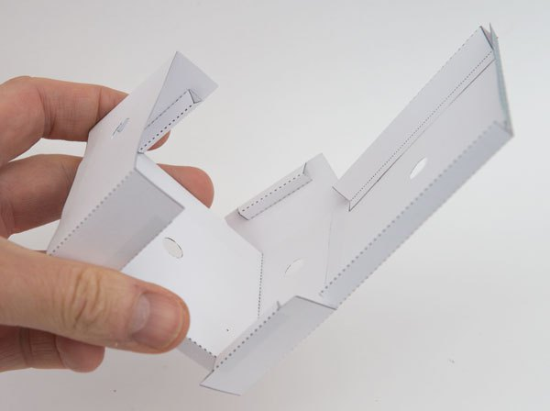

Thread the long end of the striker plate assembly up through the hole in the top of the box.
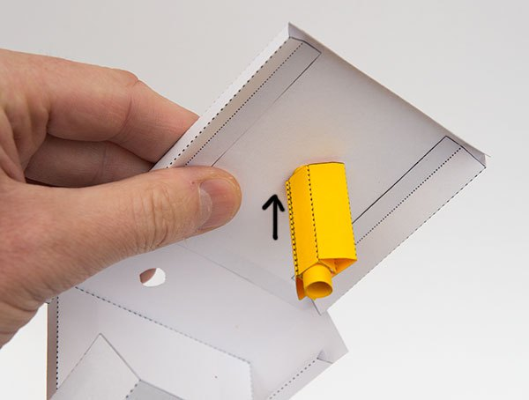

Thread the cam shaft into position between the sides.
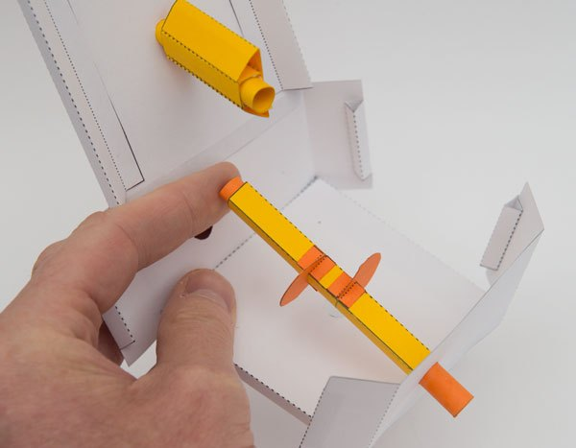
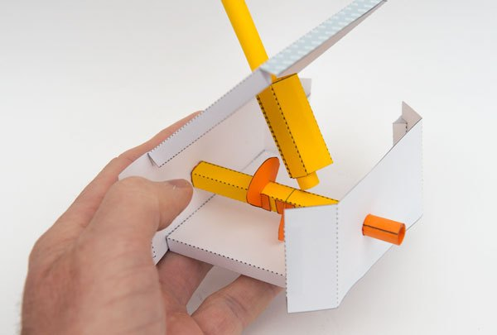

Fold down the top and glue it into place.
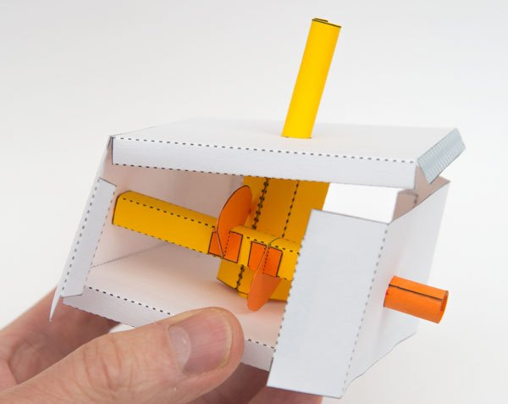
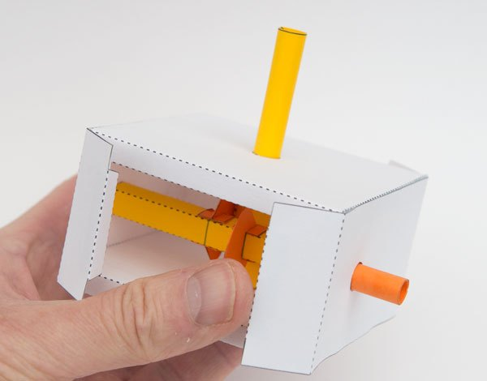

Glue down the side flaps making sure that the box is square.
Finish of the project by gluing the handle into place.

Now that you have a completed Shaker Mechanism, why not design and make a character to fit onto it and bring to life!
